Environmental Policy

DataLase Ltd recognises its responsibility to the environment beyond legal & regulatory requirements. We are committed to reducing our environmental impact & continually improving our environmental performance as an integral part of our business strategy & operating methods.
We will encourage customers, suppliers and other stakeholders to do the same.

Responsibility:
Matt Goodwin, Operations Manager, is responsible for ensuring this environmental policy is implemented; however, all employees are responsible within their areas for ensuring the aims and objectives of this policy are met.

Policy Aim

We endeavour to:
- Comply with all relevant regulatory requirements.
- Continually improve and monitor environmental performance.
- Continually improve and reduce environmental impacts.
- Incorporate environmental factors into business decisions.
- Increase employee awareness and training.

R&D, Development and Production
We will:
- Assess the environmental impacts of the company’s activities during the R&D, development and manufacture of its products.
- Reduce the amount of waste produced.
- Reduce the consumption of raw materials and parts where possible.
- Source from in-region suppliers where possible.
- Reduce and/or limit the discharge of pollutants to water, land or air.
- Limit the noise in and around the site.

Paper and Plastics
We will:
- Minimise the use of paper and plastics in the office where possible.
- Reduce packaging as much as possible.
- Recycle all paper and plastics where possible.

Energy and Water
We will:
- Reduce the amount of water wasted.
- Turn off taps when not required.
- Reduce energy use as much as possible.
- Switch off lights and electrical equipment when not in use.
- Adjust heating and energy use.
- Consider the energy consumption and efficiency of new products when purchasing them.

Office Supplies
We will:
- Evaluate if the need can be met in another way
- Evaluate the environmental impact of any new products we intend to purchase
- Favour more environmentally friendly and efficient products wherever possible.

Transportation
We will:
- Reduce the need to travel by limiting trips to necessary ones.
- Promote car sharing to minimise carbon emissions.
- Promote travel alternatives such as email or video/phone conferencing.
- Make additional efforts to accommodate the needs of those using public transport or bicycles.
- Air freight of materials to only be used as a last resort

Maintenance and Cleaning
We will:
- Use cleaning materials that are as environmentally friendly as possible.
- Use materials in any office refurbishment that are as environmentally friendly as possible.
- Only use licensed and appropriate organisations to dispose of waste in an environmentally friendly way.

Monitoring and Improvement
We will:
- Comply with all relevant regulatory requirements.
- Continually improve and monitor environmental performance.
- Continually improve and reduce environmental impacts.
- Incorporate environmental factors into business decisions.
- Increase employee awareness through training.
- Review this policy and any related business issues at the monthly management meetings.

Culture
We will:
- Update this policy at least annually in consultation with staff and other stakeholders where necessary.
- Involve staff in implementing this policy to increase commitment and improve performance.
- Provide staff with relevant environmental training.
- Work with suppliers, contractors and subcontractors to improve their environmental performance.
- Use local labour and/or materials where available to reduce CO2 and help the community.

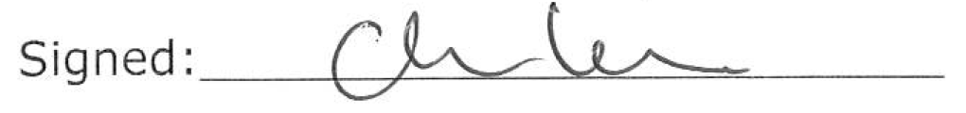 Date: 16/07/2025_
C.Lewis CEO

